MODULE 4 Assignment

Name: N.Rachana

Creating season table
- Open Power BI → Modeling tab → Click “New Table”
- Paste the given DATATABLE code in the formula bar Season =
DATATABLE(
"MonthNumber", INTEGER, "MonthName", STRING,
"Season", STRING,
{
{1, "January", "High"},
{2, "February", "Shoulder"},
{3, "March", "Shoulder"},
{4, "April", "Low"},
{5, "May", "High"},
{6, "June", "Low"},
{7, "July", "High"},
{8, "August", "Shoulder"},
{9, "September", "Low"},
{10, "October", "Shoulder"},
{11, "November", "Low"},
{12, "December", "High"}
}
)
- Press Enter to create the table
- Go to Data View to verify the Season table is created
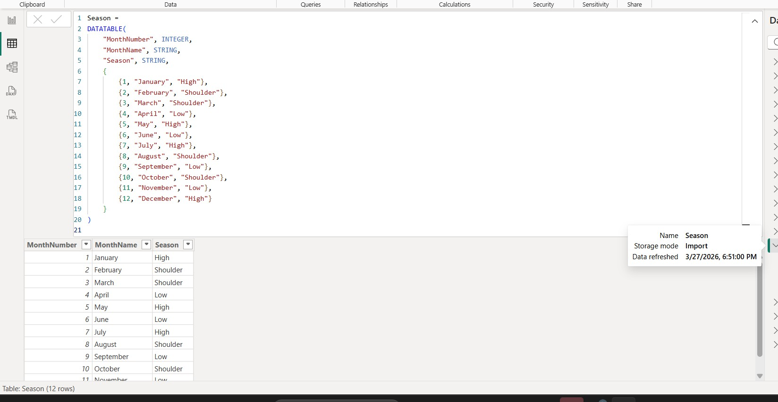

Creating Monthly bookings

- Open Power BI → Modeling tab → Click “New Table”
- Paste the given DATATABLE code in the formula bar MonthlyBookings =
SUMMARIZE (
Booking_Details,
Booking_Details[MonthStart],
"TotalRoomsBooked", SUM(Booking_Details[Room Booked])
)
- Press Enter to create the table
- Go to Data View to verify the Monthly bookings table is created
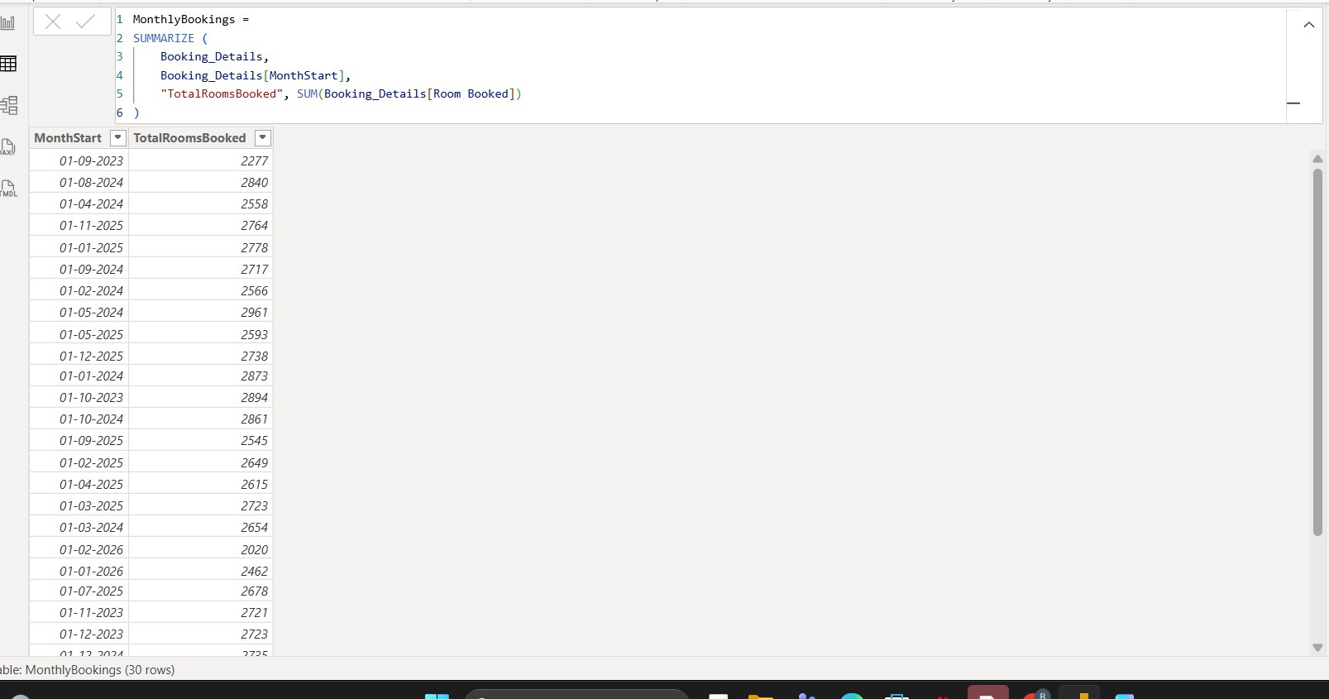

Add New Columns in Bookings Table
- Go to Data View in Power BI
- Select the Bookings table
- Click on New Column
- Paste the formula → Press Enter
- Repeat the same steps for each column below

Columns to Create CancellationFlag
CancellationFlag =
IF(Bookings[BookingStatus] = "Cancelled", "Yes", "No")

NoShowFlag

NoShowFlag =
IF(Bookings[BookingStatus] = "No-Show", 1, 0)

RefundAmount
RefundAmount = IF(
Bookings[BookingStatus] = "Cancelled", Bookings[Revenue],
0
)

RefundFlag
RefundFlag =
IF(Bookings[RefundAmount] > 0, 1, 0)

BookingDate
BookingDate =
VAR CheckInDate = Bookings[CheckInDate]
VAR PriorMonthDate = EOMONTH(CheckInDate, -1) + 1
VAR DaysBetween = DATEDIFF(PriorMonthDate, CheckInDate, DAY) VAR RandomOffset = RANDBETWEEN(0, DaysBetween)
RETURN PriorMonthDate + RandomOffset
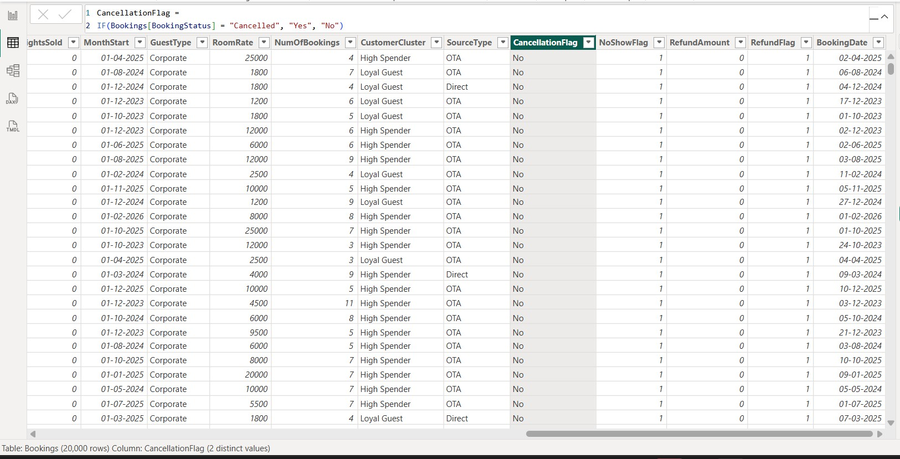

Steps to Add Measures in Bookings Table
- Go to Report View or Data View

- In the Fields pane, select Bookings table
- Click on New Measure
- Paste one formula and press Enter
- Repeat the same steps for each measure

Measures to Create
- Bookings
Bookings =
COUNTROWS(Bookings)

CancellationRate
CancellationRate = DIVIDE(
COUNTROWS(
FILTER(Bookings, Bookings[CancellationFlag] = "Yes")
),
COUNTROWS(Bookings)
)

NoShowCount
NoShowCount = CALCULATE(
COUNTROWS(Bookings),
Bookings[BookingStatus] = "No-Show"
)

Recommended Price
Recommended Price = VAR BaseADR = [DADR]
VAR SeasonAdj = SWITCH(
SELECTEDVALUE('Date'[Season]), "High", 0.15,
"Shoulder", 0.05,
"Low", -0.10,
0
)
VAR Uplift = [Price Uplift % Value]
VAR Elasticity = [Occupancy Sensitivity Value]

RETURN
BaseADR * (1 + SeasonAdj + Uplift) * Elasticity

RefundCount
RefundCount = CALCULATE(
COUNTROWS(Bookings),
Bookings[RefundAmount] > 0
)
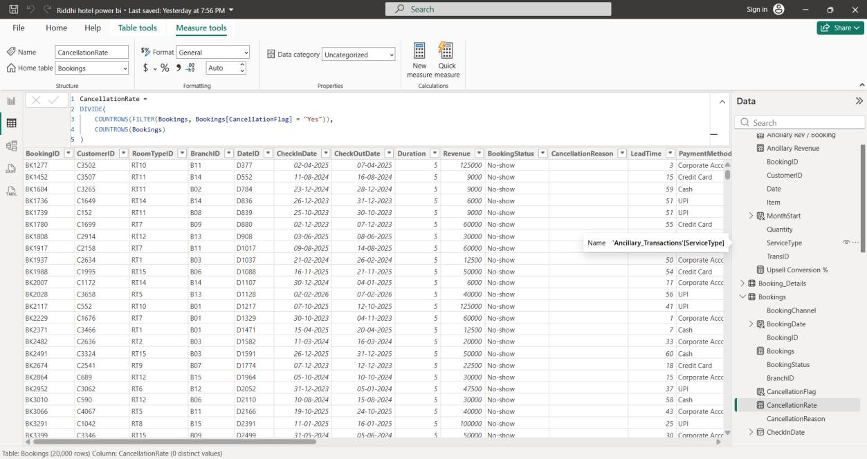

Creating Visuals
Steps to Create Line Chart with Forecast Step 1: Insert Line Chart
  - Select Line Chart
  - Drag:
    - StayDate → X-axis
    - Occupancy % → Y-axis
  - Click dropdown on Occupancy → set to Average

Step 2: Fix X-Axis (Very Important)
- Click on StayDate (X-axis)
- Select:
  - StayDate (not Date hierarchy)

- Go to Format → X-axis
  - Type → Continuous

Step 3: Basic Formatting
- Go to Format
- Turn ON:
  - Markers
  - Data labels (optional)
- Add title:
  - Average Occupancy by StayDate

Step 4: Add Forecast
- Select the line chart
- Open Analytics pane (magnifying glass icon)
- Find Forecast → Click Add

Step 5: Configure Forecast
Set:
  - Forecast length → 3 or 6 Months
  - Confidence interval → 95%
  - Seasonality → Auto (or 12 for monthly data)
  - Ignore last → 0

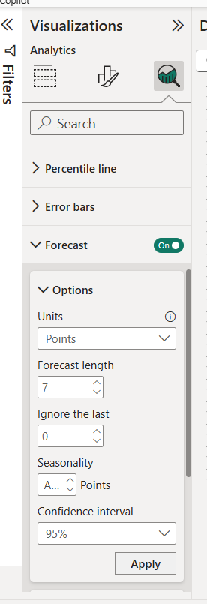
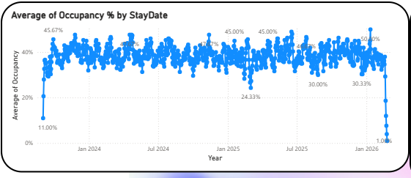

Cancellation Rate by MonthStart (Line Chart) Steps:
  - Select Line Chart
  - Drag:
    - Axis → MonthStart
    - Values → CancellationRate (measure)
  - Format:
    - Turn ON markers
    - Title: CancellationRate by MonthStart

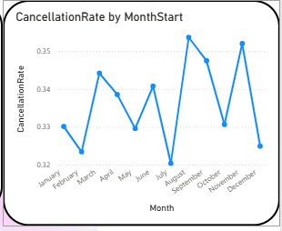

Count of BookingID by LeadTime (Bar Chart) Steps:
  - Select Clustered Bar Chart
  - Drag:
    - Y-axis → LeadTime
    - X-axis → BookingID (Count)
  - Sort:
    - Click on visual → Sort by BookingID (Descending)
  - Title: Count of BookingID by LeadTime

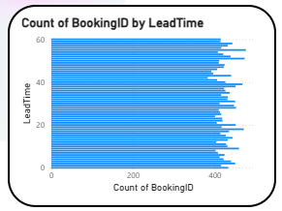

RefundCount and NoShowCount by MonthStart (Stacked Column Chart) Steps:
  - Select Stacked Column Chart
  - Drag:
    - Axis → MonthStart
    - Values → RefundCount, NoShowCount
  - Format:
    - Turn ON Legend
    - Title: RefundCount and NoShowCount by MonthStart

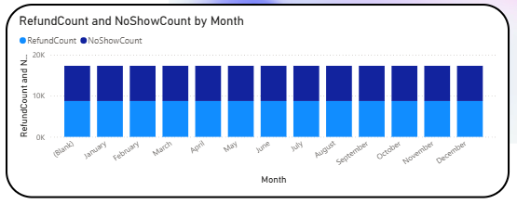

Final Dashboard
